The 2018 ARRL Teachers Institute on Wireless Technology
Expenses Paid Professional Development Opportunity

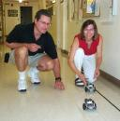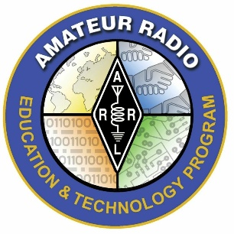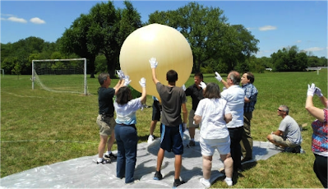

Teachers Institute opportunities are virtually free for the participants. The grant to attend a TI covers transportation, hotel, a modest per-diem to cover meals. Instructional resources for the electronics, microcontroller, and robotics segments of the course, and a resource library of relevant ARRL publications are provided to participants of the introductory Teachers Institute (TI-1). Hands-on instructional resources and equipment applicable to the topic of the advanced Teachers Institute (TI-2) are also provided through donations to the Education & Technology Program Fund and through in-kind contributions from our industry partners. A $100 enrollment fee is required.
.

Applicant Eligibility
Applicants must be teaching in a school, college, or professional educational organization serving grade levels 4-12+, or leading a school-affiliated enrichment program in an official capacity.
An Amateur Radio license is NOT required to attend the introductory seminar (TI-1), but IS required to attend the advanced Teachers Institute seminars.
Applying for the Teachers Institute
Download and complete the application and the pre-workshop survey. Send a cover letter on school letterhead, signed by you and a school administrator, stating that you would like to attend, along with the application. Please be sure to review the requirements and the reimbursement guidelines provided in the application. A $100 enrollment fee is required. (The enrollment fee will be returned if you are not accepted or upon your completion of the Institute.)
Application deadline is May 1, 2018.
Register with us to receive our e-newsletter with news from classrooms and notifications about Education & Technology Program opportunities.

Class sizes are limited-- don’t delay.

Summer 2018 Teachers Institute
Session Location Dates Instructor
TI – 2 Newington, CT July 9th – July 12th Matt Severin
TI – 1 Dayton, OH July 16th – July 20th Larry Kendall
TI – 1 Newington, CT July 23rd – July 27th Tommy Gober

http://www.arrl.org/teachers-institute-on-wireless-technology for more information

Introduction to Wireless Technology Curriculum and Agenda

Monday / Day 1
I. Introductions & Logistics
II. Educational Context for Wireless Technology
III. Basic Electronics
IV. Soldering 101 (24-hour digital clock kit)
Tuesday / Day 2
I. Day 1 Review
II. Understanding Signals - The Science of Wireless Technology
III. Digital Signal Processing (DSP) Fundamentals
IV. Radio applications in the Classroom (satellites, foxhunt, HF, EmComm, etc.)
Wednesday / Day 3
I. Day 2 Review
II. Introduction to microcontrollers
III. Programming fundamentals
IV. Input/Output circuits
Thursday / Day 4
I. Day 3 Review
II. Programming concepts
III. Robot Assembly
IV. Motion and servos
V. Robot navigation

Friday / Day 5
Note: anything that was not completed on Days 1-4 will “flow” to Day 5 for completion.
I. Day 4 Review
II. Advanced robotics projects/builds
III. Complete paperwork (survey, expense reports, etc.)
IV. Participant action plans
V. Program feedback
Throughout the program, participants will learn about application topics such as working with your local ham radio club, career/scholarship opportunities for students, the Education & Technology Program grants criteria, and what to expect if you participate in the TI-2 Session.

